  



**SMART INDIA HACKATHON**

**Ministry/Organization Name/Student Innovation: Department of Space, Indian Space Research Organisation**

**PS Code: SS612**

**Problem Statement Title: Prediction of TEC Variations with Artificial Intelligence using Space Weather Data as input**

**Team Name: AZTECH ALURE**

**Team Leader Name: RASHI JAIN Institute Code (AISHE):**

**Problem Category: Software**

**Theme Name: Disaster Management**

**PROTOTYPE**

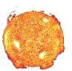Get data of Solar Flares using public sources &prepare dataset

Get F10.7 data,Interplanatery Data & Magnetic field at Geomagnetic Equator

Input Geographical Location

Predict the TEC variation with Solar Storm Interval acc. to Season using Naive Bayes& Decision Tree

Get Sunspot Cycle (Seasonal & Diurnal) with Geographical Location (Polar,Auora zones)

Get Solar Storm interval from public domain & preapre Dataset

Predict the TEC variation with F10.7 & Magnetic Field & Location using XGBooster Algorithm

Predict the TEC variation with Location & Solar Flare using LSTM model

TEC Variation

TEC Variation

**Predict the TEC variation with Solar Storm interval according to Season**

XG BOOSTER

**Predict the TEC variation with F10.7 & Magnetic Field & Location**

DATABASE

Predict the TEC variation with combined effect using Neural Network

TEC Variation

LSTM

**Predict the TEC variation**

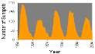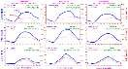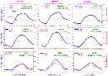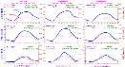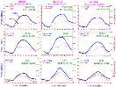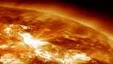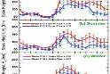

**with Location & Solar Flare**

NEURAL NETWORK

**Predict the TEC variation with combined effect**

Test dataset

Training dataset

USE CASE



## Login

**Register**

## PUBLIC USER

**Update Dataset**

**of TEC**

**Update Datasets of different parameters like Solar Activity**

**,Magnetic Field**

**,Geolocation etc.**

**Get Predicted**

**Value of TEC**

**Update Dataset of TEC**

## SPACE AGENCY



SOLUTION APPROACH

* First of all we are developing the solution for **Prediction of TEC(Total Electron Count)**

## using Deep Learning Models-AI(Artificial Intelligence).

* We are developing the web application that is developed using **Django framework** and

**HTML CSS** for showing the predicted value of TEC.

* First we prepared the data set of TEC **with input parameters like Solar Flare, Solar Storm. Interval, F10.7, Interplanetary Data, GNSS Signal Delay, Magnetic Field for the desired location.**
* First we will **input geographical location**.

## Predict the TEC variation with Solar Storm Interval according to Season using Naive Bayes& Decision Tree.

* Predict the **TEC variation with F10.7 & Magnetic Field & Location using XGBooster. Algorithm**

## Predict the TEC variation with Location & Solar Flare using LSTM model.

* Predict the **TEC variation with combined effect using Neural Network.**
  + Box2Eectron

Total number of electrons in a column

with cross section of 1m2

(1 TECU = 1016 electrons/m2)

1. **Total Electron Content (TEC)**

**1m2**

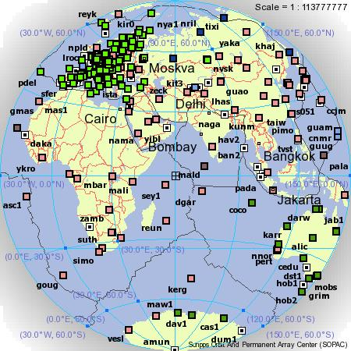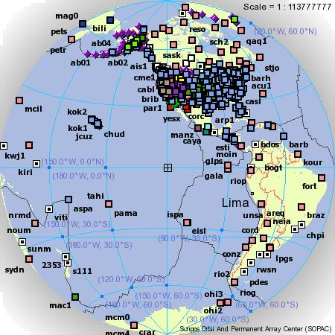

1. **TEC Measurements**

* Use Ionospheric effects on radio wave propagation
  + **Ionospheric effects on GPS signals**
  + Time delay of signal
  + Phase advance of carrier wave
* Use Ionospheric effects on radio wave propagation
  + **Faraday rotation** of the polarization angle of a radio wave
  + → Require magnitude of the geomagnetic field

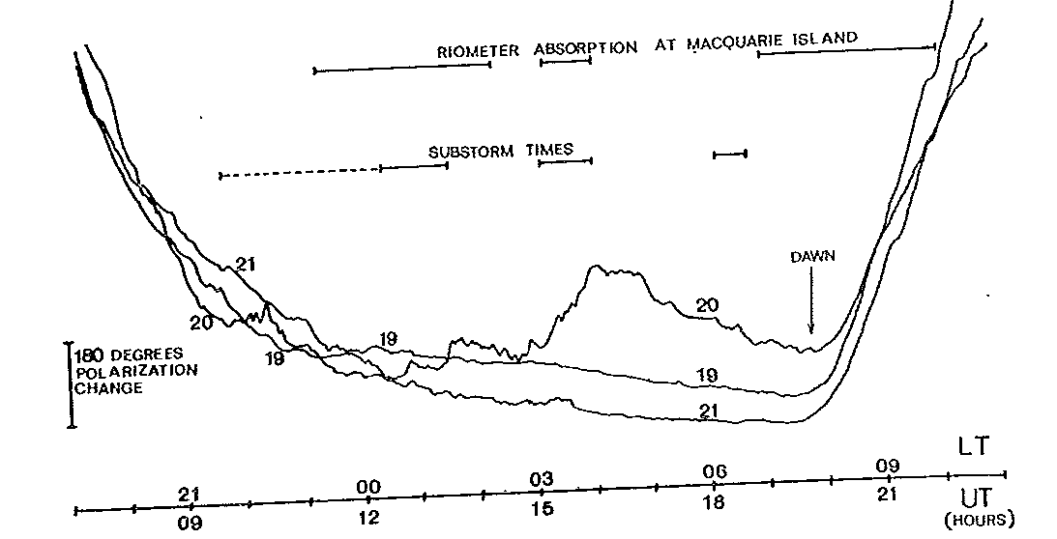

180o = 2.5 TECU

1. **TEC Measurements**
2. **Many ways to get GPS Biases**
3. Least-Squares
4. Kalman Filter

- University Bern Astronomisches Institute

* + - - (http://aiuws.unibe.ch/ionosphere/)
    - - P1P2 and P1C1 files (satellite biases, IGS stations)

1. GAIM Models

- Use bias file for satellites and available stations

- Others build into Kalman filter

**Biases lead to uncertainties in absolute TEC of the order of about 1-4 TECU**

TECabs = TECrel  + DCBGPS + DCBREC

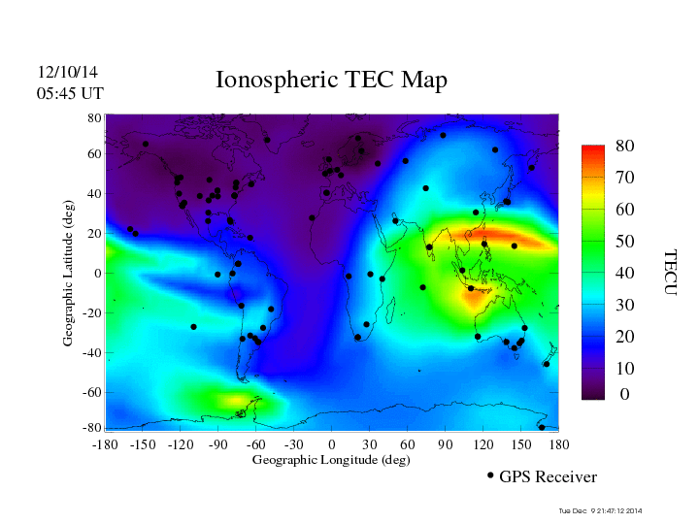

1. 2D TEC Maps

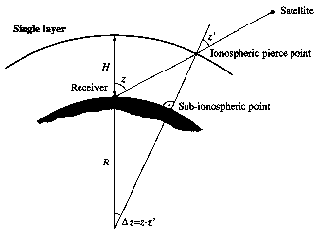

1. **Slant Total Electron Content (sTEC)**

* To convert *sTEC* to *vTEC* often a so-called single-layer model is used.
* All free electrons are assumed to be contained in a thin shell at altitude *H*.
* The altitude of this idealized layer is often set to *400 km* approximately corresponding to the altitude of maximum electron density.

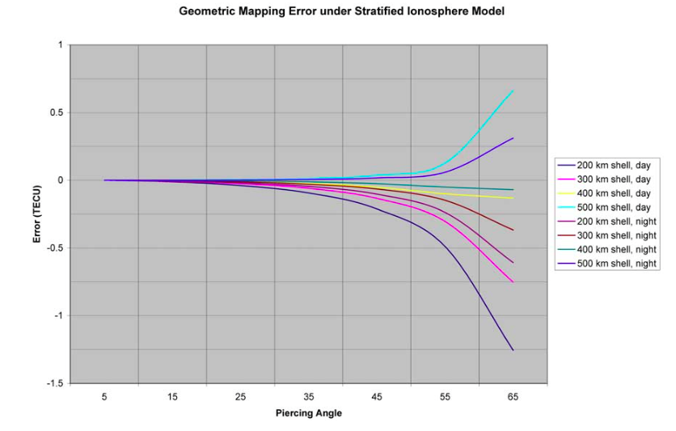

1. **Mapping of sTEC to vTEC**

Errors can reach as high as 14% on days of no strong ionosphere activity

 LSTM stands for long short-term memory networks, used in the field of [Deep Learning](https://intellipaat.com/blog/tutorial/machine-learning-tutorial/introduction-deep-learning/). It is a variety of **[recurrent neural networks (RNNs)](https://intellipaat.com/blog/tutorial/artificial-intelligence-tutorial/recurrent-neural-network/" \t "https://intellipaat.com/blog/what-is-lstm/_blank)** that are capable of learning long-term dependencies, especially in sequence prediction problems. LSTM has feedback connections, i.e., it is capable of processing the entire sequence of data, apart from single data points such as images. This finds application in speech recognition, machine translation, etc. LSTM is a special kind of RNN, which shows outstanding performance on a large variety of problems.

### ****The Logic Behind LSTM****

The central role of an LSTM model is held by a memory cell known as a ‘cell state’ that maintains its state over time. The cell state is the horizontal line that runs through the top of the below diagram. It can be visualized as a conveyor belt through which information just flows, unchanged.

Information can be added to or removed from the cell state in LSTM and is regulated by gates. These gates optionally let the information flow in and out of the cell. It contains a point wise multiplication operation and a sigmoid neural net layer that assist the mechanism.

1. **Model**

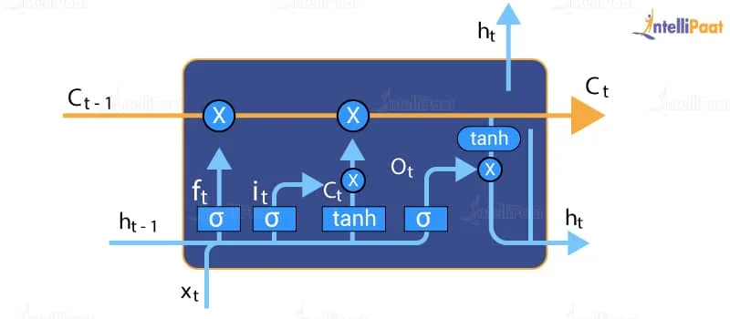

The sigmoid layer gives out numbers between zero and one, where zero means

‘nothing should be let through,’ and one means ‘everything should be let through.’





**TECHNOLOGY STACK**

Reasons to Choose PyTorch for Deep Learning | by Claire D. Costa | Towards  Data Science



**DEPENDENCIES /SHOW STOPPERS**

# Large dataset required

* + **Accuracy is not 100%**

# Depend on the ML model